ALLIANCE CHRÉTIENNE ET MISSIONNAIRE AU QUÉBEC/ST-LAWRENCE DISTRICT
INFORMATION SHEET
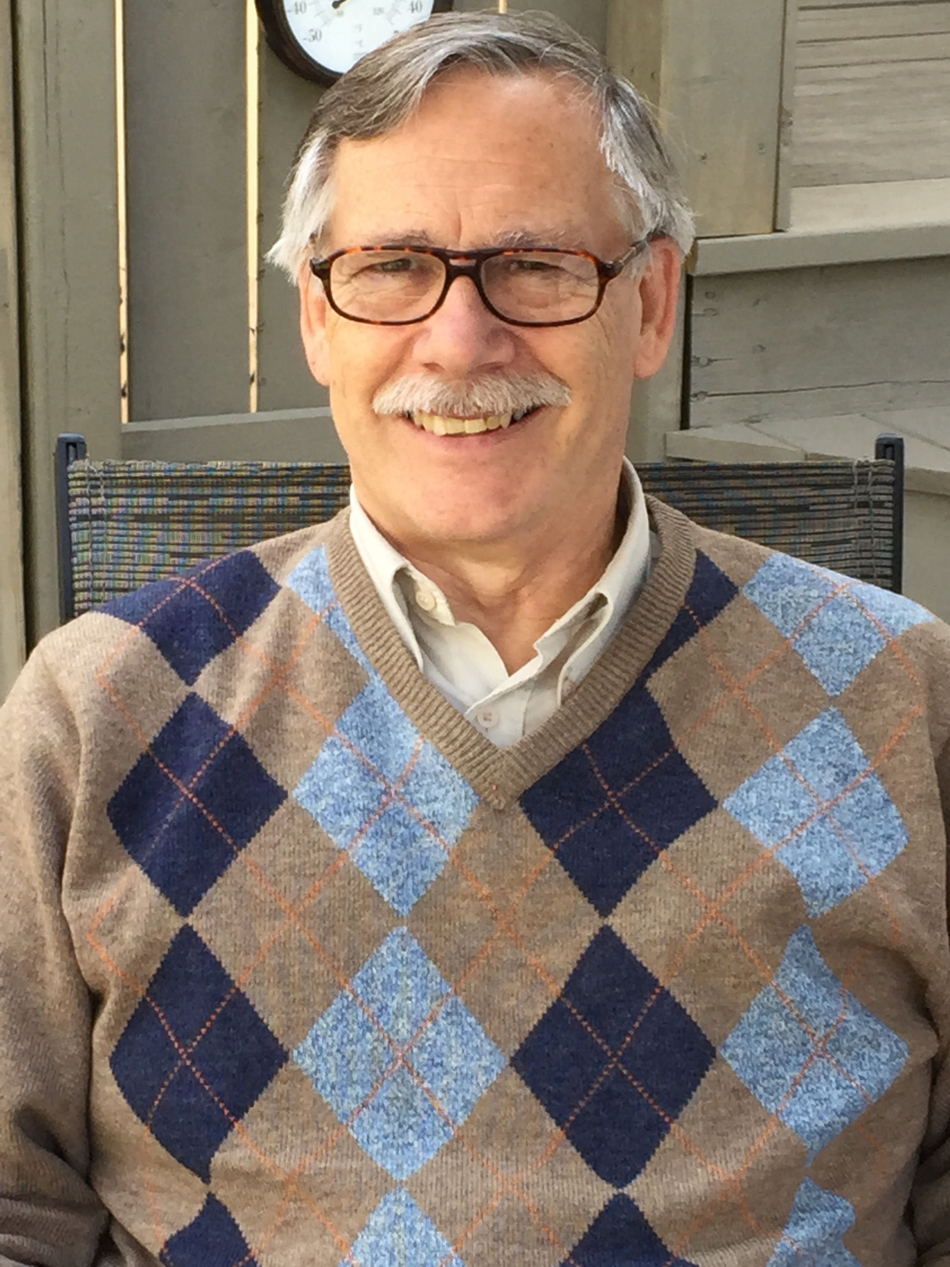
CANDIDATE FOR DISTRICT SUPERINTENDENT

Rev. Michael H. Gagnon
michaelhgagnon@hotmail.com
(581) 624-2337

Darlene and I are celebrating 44 years of marriage, this year, and we have six adult children and seventeen (17) grandchildren, with number 18 on the way (summer 2017). Family is very important for us and a great source of blessing. At 67, my health is good.

In May of this year, it will be 40 years that I have been a credentialled worker with the Christian and Missionary Alliance in Canada. These past 27 years I have served in the pastorate in Montreal, in Farnham, in Ste-Agathe des Monts and, for the past 4 years in bothe Rimouski and Matane. I have taught with ETAQ and with Bethel Bible Institute (Lennoxville) and with Capernwray Quebec (Chertsey). For many years, I held the role of administrative assistant to the Superintendent of the district. I have also served as liaison with the ethnic churches and as coach to workers and churches. For the past year, I have served as interim district superintendent. [see annex for details]

Beyond my work responsibities, I have volunteered over the years, serving on different boards and committees (CBC/CTS, St-Lawrence DEXCOM, IBVIE, Board of Directors of the C&MA in Canada, etc.). I have also volunteered in school committees, at La Macaza prison (18 yrs) and other organizations.

To borrow biblical terms, I can be described as a “pastor-teacher” and my main gifts are compassion and leadership. One of my main reasons for seeking the office of district superintendent is the sense that during this period in our history, the need is for pastoral leadership: the workers and the churches need this kind of leadership in order to enter more fully into the reality of the vision and values of the C&MA in Canada:
“O God, with all our hearts, we long for You.
Come, transform us to be Christ-centred, Spirit-empowered, Mission-focused people, multiplying disciples everywhere.”

Also, concerning the district vision:
“To reflect the values of Christ, through the power of the Holy Spirit, in order to have a holistic spiritual influence in contemporary Quebec for the Kingdom of God.”

This vision needs to serve as a point of reference for each district church. It must determin the kind of activities/ministries to be initiated by district leadership for the churchs/works they serve. The vision must guide every involvement that flows out of responsibility to district churches, with every engagement with other like-minded denominations and organizations. In sum, our desire is to see Christ glorified in today’s context. Everything must be done under the direction of the Holy Spirit with the goal of advancing the Kingdom of God in Quebec and beyond.
For this to become reality, we need to continue to encourage our workers and church leadership to personnally experience the fullness of the Holy Spirit, in order to be able to model such a lifestyle to their churches and to teach and introduce each of our faithful ones to such a life.

I believe that is through the multiplication of churches (communities of faithe) that the Kingdom of God will grow and that the local church, in order to be a living testimony to Christ, is called to demonstrated the power of the Lord of the universe toward a perishing world. This power comes from the power of the Gospel to transforme the whole person; from the fallen being we are to one who is righteous on every level. The proof of this divine work in the lives of men and women is demonstrated when they live in unity despite their differences. Thus, the local church - in each of its expressions is a necessity.
An integral part of this witness of transformation involves bringing the grace of God, the compassions of the Lord and the restoration to the social institutions and environnements that surround the church. In other words, that the believers of our churches become ‘salt’ and ‘light’ in THEIR WORLD. We need to encourage each other, as members of the C&MA family in Quebec in that direction.

For several years, now, many efforts have been invested, both at district level and at the national level, in developping strategic plans. I believe that the next period of our history as a district needs to see us focussed on the practical implimentation of these strategies. We need to bring the brothers and sisters of our churches into full participation in the C&MA ‘family’ vision. I believe that I am able to give the necessary leadership to enable our SLD workers and churches to live ‘in family’, to develop partnerships that work in order to strengthen the capacity of each church so that she can take her place in God’s mission.

That which I bring to the table, among other things is my life/ministry experience (40 years, 37 of which have been in the SLD).
My listening ear to the voice of God: desire to keep the Kingdom perspective.
My spiritual gifts: word of wisdom, encouragement(exhortation)/compassion.
My commitment to see the C&MA in Quebec move toward automony as a district.

Since I began serving as interim superintendent, I have discovered just how my gifts and my pastoral call have been used of God as I have met with situations involving individuals and churches. It is my firm conviction that our district nees a period where leadership pays attention to the needs of its workers and church leaders in order to permit them to grow into holistic maturity. I believe that I have been equipped - my gift mix - to lead our family of churches into the realisation of the declared visions/strategies.

ANNEXE MINISTÈRES/SERVICE

ALLIANCE CHRÉTIENNE ET MISSIONNAIRE:
1) Rimouski/Matane; Pasteur juillet 2013 à présent.
2) District St Laurent : Coach auprès des Églises et des ouvriers ainsi que facilitateur de la formation
continue du 1 janvier, 2011 à juillet 2013. (par contract).
3) District St Laurent : Président du réseau de développement des Églises Ethnies (multiculturel) région
de Montréal. De 2011 à présent.
4) District St Laurent : Président du réseau de développement des Églises francophones de la region de
Montréal de 2001 au 2011. (1/4 temps – 2005/2007).
5) District St Laurent : Liaison auprès des Églises Ethnies de la region de Montréal (. temps ou 1 jr/sem.)
from Août 2004 to Août 2007.
6) Farnham: Pasteur (temps partiel) de Mai 2002 à juin 2007.
7) Église ACM de Ste Agathe des Monts : Pasteur du 7 août, 1989 au 8 août 2010.
8) District St Laurent :Adjoint Administratif (. temps) Septembre1996 - Decembre 2000.
9) ÉTAQ : Assistant professor. De août 1988 à juin 1989.
10) Farnham : Pasteur d’octobre 1981 à juin 1988.
11) Montréal : Pasteur/implanteur d’Église d’octobre 1980 à octobre 1981.
12) Fort Qu’Appelle, Saskatchewan :Pasteur étudiant de Mai 1977 à mai 1980.

AUTRES
1) Enseignant: Capernwray/Porteurs du Flambeau, Chertsey Québec de 1999 à présent. Moyanant un
cours/an.
2) Prédicateur invité (1/2 fois/an) à Grace Montreal Church.
3) Conférencier de camp: Camps familiaux & retraites à Porteurs du Flambeau, Chertsey Québec depuis
1993.
4) Aumônier remplaçant: Établissement La Macaza, Québec pendant deux étés.
5) Professeur (temps partiel) : Institut biblique Béthel, Lennoxville, Québec 1985-1988.

